Q.1 In MySQL, Create a database in your name and then create a table called STUDENT containing columns ROLLNO (roll number), NAME (Student’s name), ADDR (Student’s address) and PHONE (Phone number). Add five rows to this table. Execute a query for the following:
To Display roll number, name of all the students
Q.2 In a factory weekly wages of workers is calculate as follows:-First 35 hrs are considered as regular hrs. Hrs exceeding 35 hrs are considered as overtime. Write a C Program to input worker’s name(wn),hrs worked(hr) and rate per hr(r), then print name and total wages(tw). Overtime wages is paid @ 2 times the rate.
Q.3 Create the following worksheet showing Product Name ,Unit cost in columns A and B. Compute selling price in column C when profit percentage is entered in cell D9. Show the formula to the examiner.
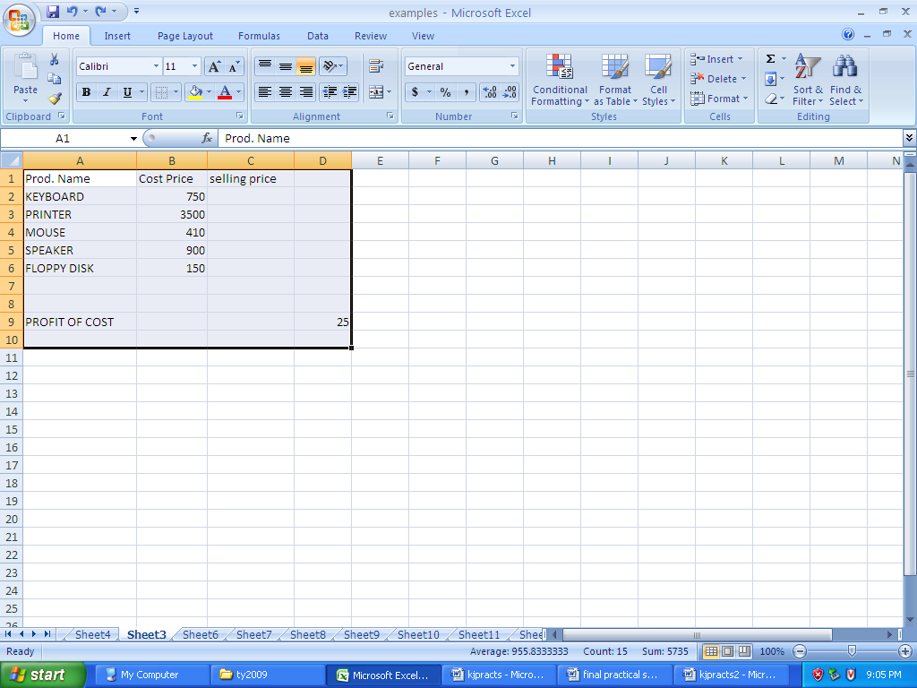

Q.1 In MySQL, Create a database in your name and then create a table called EMPLOYEE containing columns EMP_ID( employee id primary key) EMP_NAME( employee’s name ) and DOJ( Date of joining ).
Add five rows to this table.
Execute query for the following:
(i) Insert a row into this table.
(ii) Add a new column called EMAIL_ID to the table.

Q.2 A chemical company offers commission to their salesmen as @ 5% of the sale amount. In order to boost the sale, company offers an additional commission (ac) @ 3% of amount exceeding Rs 10,000. Write a C Program to input salesman name(sn), total sales(ts) and print his name, commission(c)and additional commission (ac) .

Q.3 Create the following worksheet showing Product Name ,Unit cost and % of profit in columns A ,B and C. Show steps to compute selling price in column D. Show the formula to the examiner.

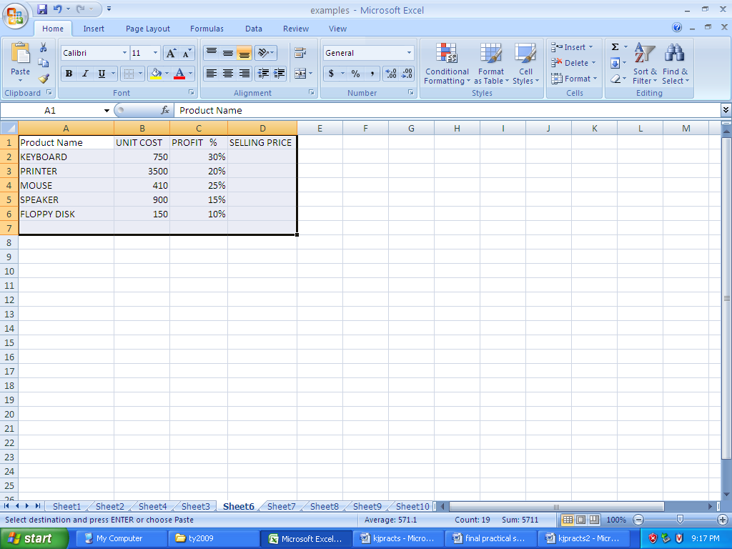
Q.1 In MySQL, Create a database in your name and then create a a table called STUDENT containing columns ROLLNO (roll number), NAME (Student’s name) and PHONE (Phone number).
Add five rows to this table
Execute a query for the following:
(i)Display structure of the table STUDENT.
(ii) Rename the table as STUDENT1.

Q.2 In a certain state sales tax is calculated on the basis of sales as follows:
Sales Sales tax
First 5000 2 %
Next 20000 5 %
Excess 8 %
Write a C Program to input sales amount(s) and print sales amount(s) , sales tax(t) and total amount(ta).

Q.3 Create the following worksheet showing Account no. , Name, Deposit amount, yearly rate of interest and no. of days of deposit. Write steps to compute simple interest in column F assuming 365 day year.
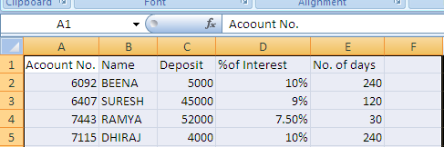

Q.1 In MySQL, Create a database in your name and then create a table called EMPL containing columns EMP_ID (employee id primary key) E_NAME (employee’s name) DEPT_ID (department id).
Add five rows to this table.
Execute a query for the following:
(i)Display rows in alphabetical order of name.
(ii)Delete the table EMPL .
Q.2 A wholesaler offers discount on basis of order amount. The order amount and discount rate is as follows:-
ORDER AMOUNT DISCOUNT RATE
Up to Rs 10000 5%
Above 10000 10%
Write a C Program to input customer order amount (a) and then print order amount, discount (d) and net amount (n).
Q.3 Create the following worksheet showing Account no. , Name, Deposit amount, yearly rate of interest and no. of years of deposit. Show steps to find Future Value in Column F.
Show the formula to the examiner.
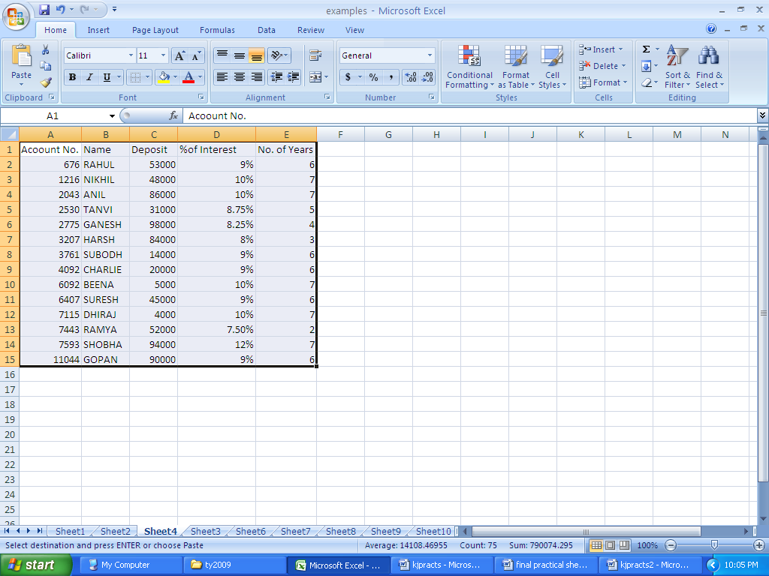
Q.1 In MySQL, Create a database in your name and then create a table called EMPL containing columns EMP_ID (employee id primary key) EMP_NAME (employee’s name) and SALARY (salary). Add five rows to this table.
Execute a query for the following:
(i)Increase salary of each employee by 2000.
(ii)Rename column SALARY as PAY.

Q.2 Write a C program to input Employee name (nm) and his basic pay(P) and then print his name and Bonus, Where bonus is 80% of basic or Rs. 3500, whichever is less.

Q.3 Create the following worksheet showing cost, scrap value and life of a machine. Show steps to compute depreciation using straight line approach in column E.
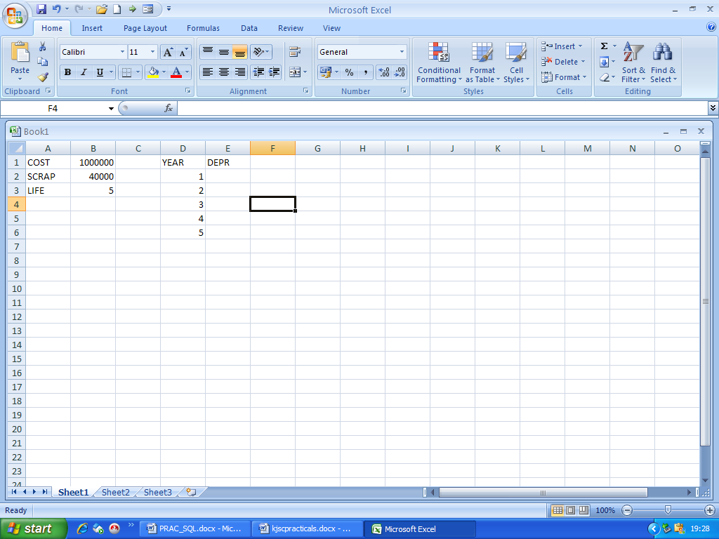

Q.1 In MySQL, Create a database in your name and then create a table EMPL containing columns EMP_ID (employee id primary key) EMP_NAME (employee’s name) DEPT_ID (department id), DOJ (date of joining).
Add five rows to this table.
Execute a query for the following:
- Display employee id, employee name of employees.

- Display employee id, employee name and date of joining of those employees whose name contains letter “S”.
Q.2 Write a C Program to input Name and basic pay of an employee and then print name, HRA and Special allowance. HRA is 20% of basic or Rs. 7000/ whichever is less and Special allowance is 10% of basic pay whenever basic exceeds Rs 10000. Otherwise it is 5% of basic pay.

Q.3 Create the following worksheet showing cost, rate of depreciation and life of a machine. Prepare a depreciation table using reducing balance method in column E. Show WDV in column F. Show the formula to the examiner.
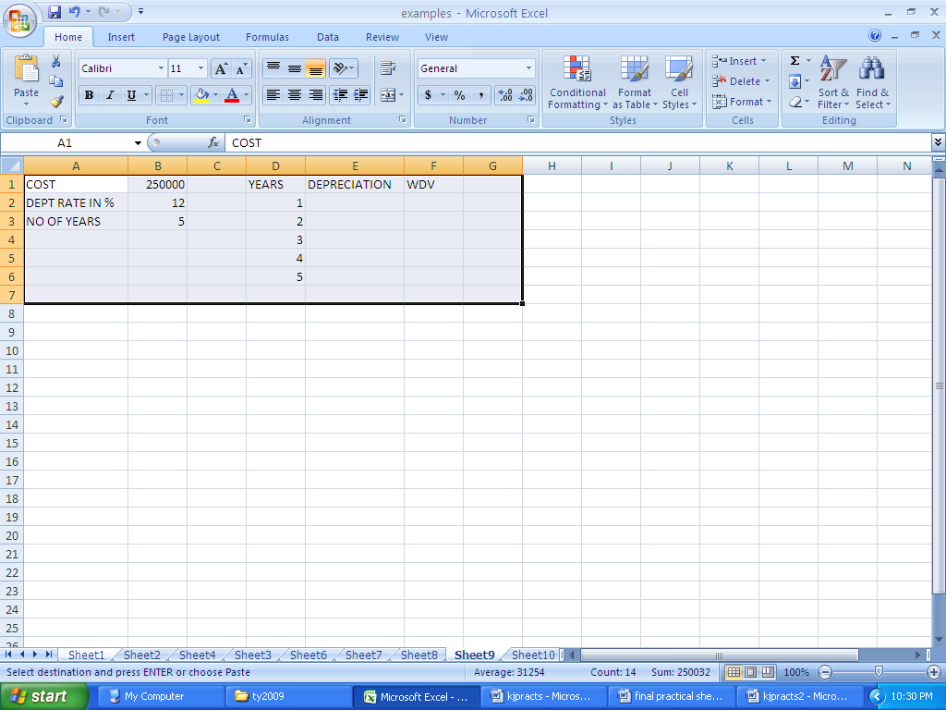

Q.1 In MySQL, Create a database in your name and then create a table EMPL containing columns EMP_ID (employee id primary key) EMP_NAME (employee’s name) and SALARY (salary).
Add five rows to this table
Execute a query for the following:
(i) Display employee id, employee name and salary of 2 highest paid employees.
(ii) Display all the row where salary is more than 10000.

Q.2 Write a C program to input Name, basic pay and then print name and bonus where the bonus is 40% of basic pay.

Q.3 In excel explain the steps to find future value of an investment of Rs.500/- per month for a period of 4 years when annual rate of interest is 6%.
Show the formula to the examiner.
Ans: 27,048.92

Q.1 In MySQL, Create a database in your name and then create a table called STUDENT containing columns ROLLNO (roll number), NAME (Student’s name), MAR1,MAR2( marks in 2 tests).
Add five rows to this table.
Execute a query for the following:
(i)To Display roll number, name total marks of all the students.
(ii) To display average marks in each test.

Q.2 Write a C Program to input worker’s name(wn),hrs worked(hr) and rate per hr(r), then print name and wages(w).

Q.3 Create the following worksheet showing Employee Name ,Salary in columns A and B.
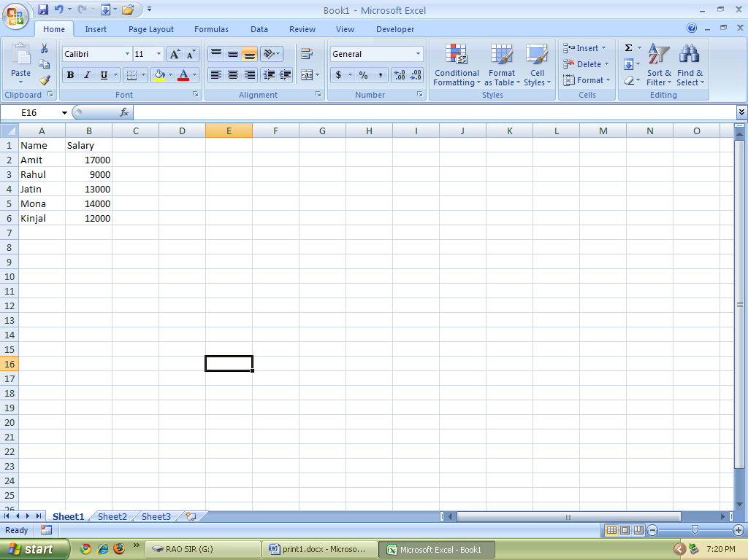
Show steps to compute HRA in column C @25% of Salary or Rs. 2500 whichever is less, DA in column D as 35% of salary.

Q.1 In MySQL, Create a database in your name and then create a table called EMPLOYEE containing columns EMP_ID( employee id primary key) EMP_NAME( employee’s name ) and DOJ( Date of joining ).
Add five rows to this table.
Execute query for the following:
(i) Insert a new column PHONE to store phone numbers to this table.
(ii) To change the column name of EMP_NAME to E_NAME.

Q.2 Write a C program to input roll no. and marks in two tests and print roll no. and total marks.

Q.3 Create the following worksheet showing Area and sales
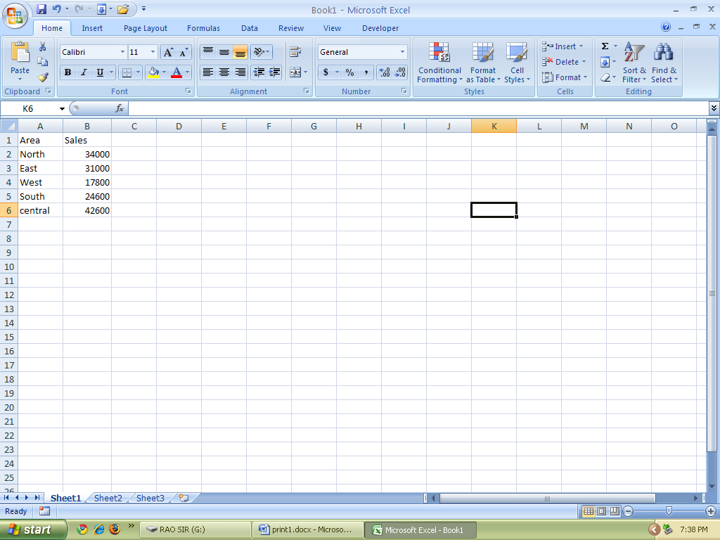
Create a 3-D Pie chart to this table. And show the chart to the examiner.

Q.1 In MySQL, Create a database in your name and then create a table called STUDENT containing columns ROLLNO (roll number), NAME (Student’s name) and PHONE (Phone number).
Add five rows to this table
Execute a query for the following:
(i)Display structure of the table STUDENT.
(ii) Rename the table as STUDENT1.

Q.2 Sales tax is calculated on the basis of sales as follows:
Sales Sales tax
Upto Rs 5000 2 %
Above Rs. 5000 3%
Write a C Program to input sales amount(s) and print sales amount(s) , sales tax(t) and total amount(ta).

Q.3 Create the following worksheet showing Employee no. and Basic Pay
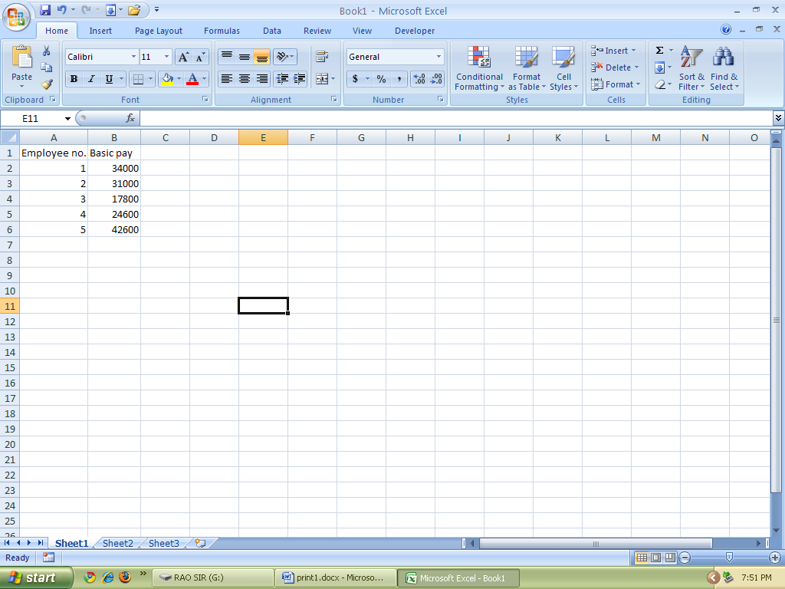

Calculate bonus @25% of basic pay when basic pay is less than Rs. 30000 otherwise @20% of basic pay.

Q.1 In MySQL, Create a database in your name and then create a table called EMPL containing columns EMP_ID (employee id primary key) E_NAME (employee’s name) DEPT_ID (department id).
Add five rows to this table.
Execute a query for the following:
(i)Display rows in alphabetical order of name.
(ii)Delete the table EMPL .
Q.2 A wholesaler offers discount on the basis of order amount. The order amount and discount rate is as follows:-
ORDER AMOUNT DISCOUNT RATE
Up to Rs 10000 5%
Above 10000 10%
Write a C Program to input customer order amount (a) and then print order amount, discount (d) and net amount (n).
Q.3 Create the following worksheet showing Account no. , Name, Deposit amount, yearly rate of interest and no. of years of deposit. Show steps to find Future Value in Column F.
Show the formula to the examiner.
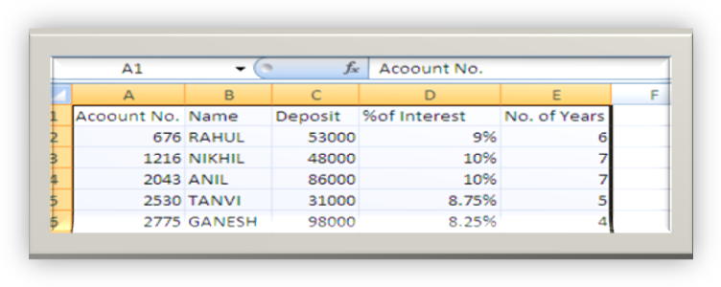
Q.1 In MySQL, Create a database in your name and then create a table called EMPL containing columns EMP_ID (employee id primary key) EMP_NAME (employee’s name) and SALARY (salary). Add five rows to this table.
Execute a query for the following:
(i)Increase salary of each employee by 2000.
(ii)Rename column SALARY as PAY.
Q.2 Write a C program to input Employee name (nm) and his basic pay(P) and then print his name and Bonus, Where bonus is 80% of basic or Rs. 3500, whichever is less.
Q.3 Create the following worksheet showing cost, scrap value and life of a machine. Show steps to compute depreciation using straight line approach in column E.

Q.1 In MySQL, Create a database in your name and then create a table EMPL containing columns EMP_ID (employee id primary key) EMP_NAME (employee’s name) DEPT_ID (department id), DOJ (date of joining).
Add five rows to this table.
Execute a query for the following:
- Display employee id, employee name of employees.

- Display employee id, employee name and date of joining of those employees whose name contains letter “S”.

Q.2 Write a C Program to input Name and basic pay of an employee and then print name, HRA and Special allowance. HRA is 20% of basic or Rs. 7000/ whichever is less and Special allowance is 10% of basic pay whenever basic exceeds Rs 10000. Otherwise it is 5% of basic pay.

Q.3 Create the following worksheet showing cost, rate of depreciation and life of a machine. Prepare a depreciation table using reducing balance method in column E. Show WDV in column F. Show the formula to the examiner.
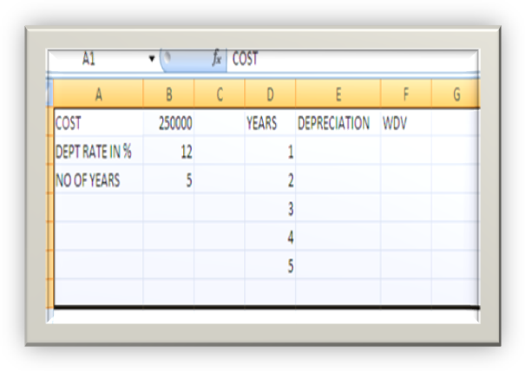
Q.1 In MySQL, Create a database in your name and then create a table EMPL containing columns EMP_ID (employee id primary key) EMP_NAME (employee’s name) and SALARY (salary).
Add five rows to this table
Execute a query for the following:
(i) Display employee id, employee name and salary of 2 highest paid employees.
(ii) Display all the row where salary is more than 10000.

Q.2 Write a C program to input Name, basic pay and then print name and bonus where the bonus is 40% of basic pay.

Q.3 In excel explain the steps to find future value of an investment of Rs.500/- per month for a period of 4 years when annual rate of interest is 6%.
Show the formula to the examiner.

Q.1 In MySQL, Create a database in your name and then create a table BANK containing columns CUS_ID (Customer id primary key) C_NAME (Customer’s name) depo (deposit amount) and DOD (date of deposit) .
Add five rows to this table
Execute a query for the following:
- Display Customer id, name where deposit amount is more than 5000.
- Add a new column IRATE to store interest rate and update this field by storing rate as 12 in every row.

Q.2 Write a C Program to input a letter and print whether it is ‘A’ or ‘a’ or Not.
Q.3 Create the following worksheet in a Excel worksheet:
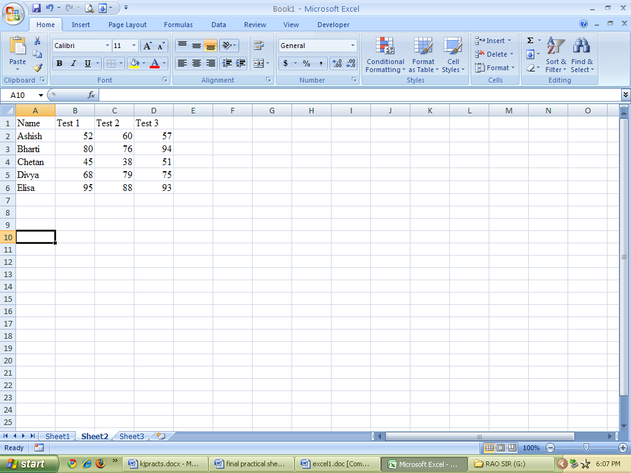
a) Find Average in Column E
b) Assign letter Grade in Column F using VLOOKUP() when policy is :
Average Score Grade
80 or more A
65 to 79.999 B
Less than 65 C

Q.1 In MySQL, Create a database in your name and then create a table SALES containing columns SALES_ID (salesman id primary key) S_NAME ( name) and TSALES (Total sales).
Add five rows to this table
Execute a query for the following:
(i) Display salesman id, name and total sales for those whose total sales is between 15000 and 25000.
(ii)Show all the rows in descending order of sales.

Q.2 Write a C Program to find the sum of

Q.3 Create the following worksheet showing data:

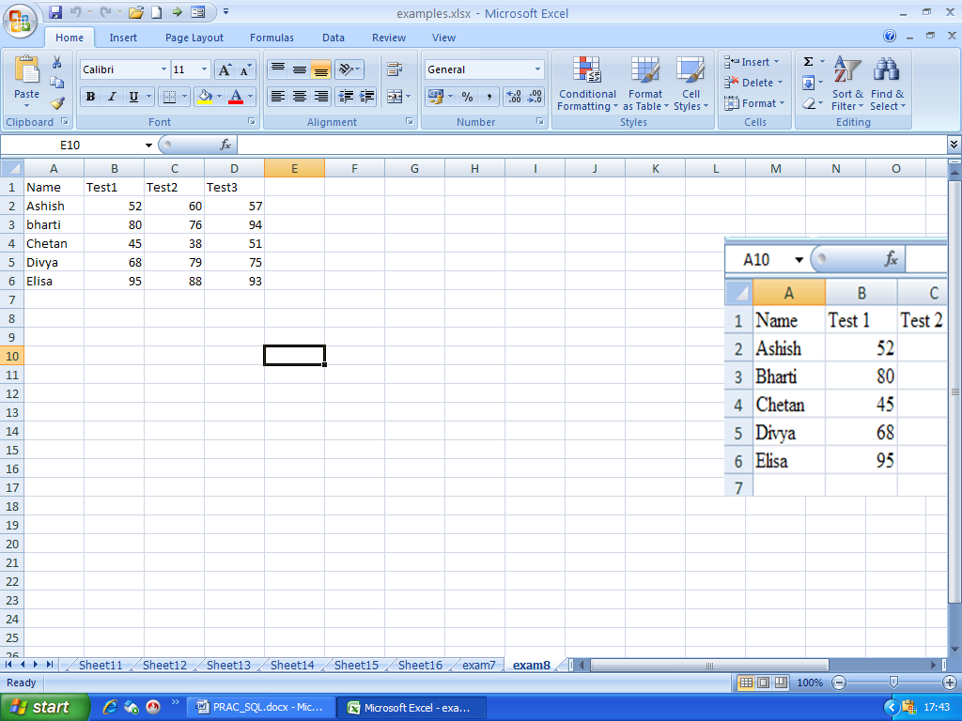

1) Find total and average in columns E and F.
2) Using function show highest mark of Test1 in cell A8 and least mark of Test 2 in cell A9

Q.1 In MySQL, Create a database in your name and then create a table SALES containing columns SALES_ID (salesman id primary key) S_NAME ( name) and TSALES (Total sales).
Add five rows to this table
Execute a query for the following:
- Add one new column COMMI to the table to store commission.
(ii) Update the column commission as 3% of total sales.

Q.2 Write a C Program to input name and basic pay and print name and bonus where bonus is 25% of Basic.

Q.3 Create the following worksheet showing
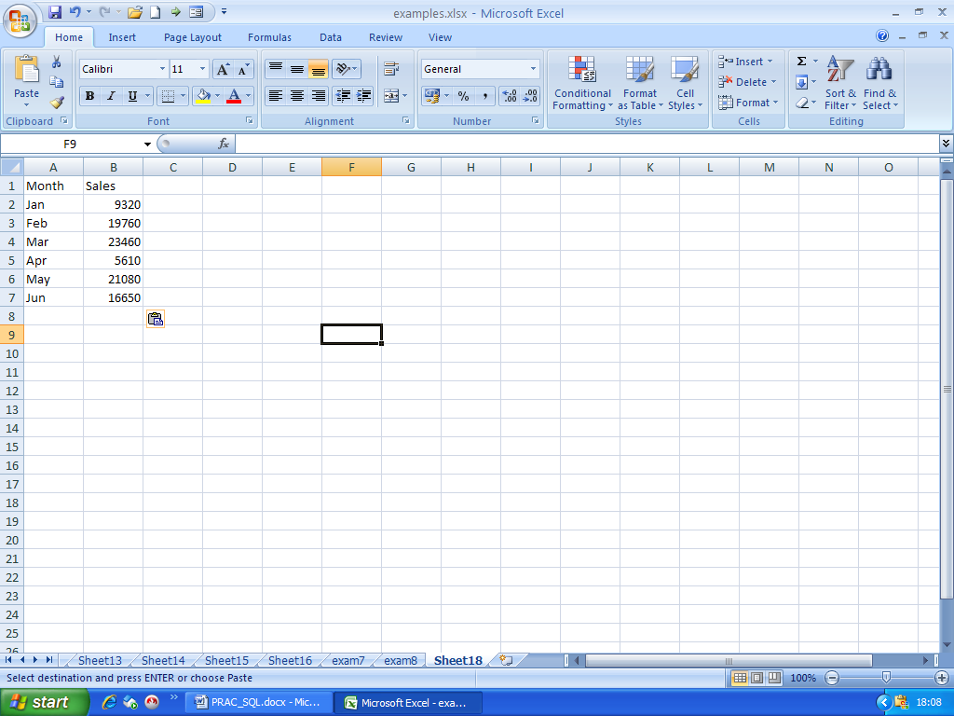
Construct the following charts to display Month along X Axis and sales of the along Y Axis:
(a) A 3-D column chart
(b) A Line chart
(Show appropriate axis titles)

Q.1 In MySQL, Create a database in your name and then create a table SALES containing columns SALES_ID (salesman id primary key) S_NAME ( name) and TSALES (Total sales).
Add five rows to this table
Execute a query for the following:
- To show sum and average of total sales of all the employees.
- To display names of all salesmen whose names begin with the letter A

Q.2 Write a C program to print numbers from 1 to 100.
Q.3 Create the following worksheet showing
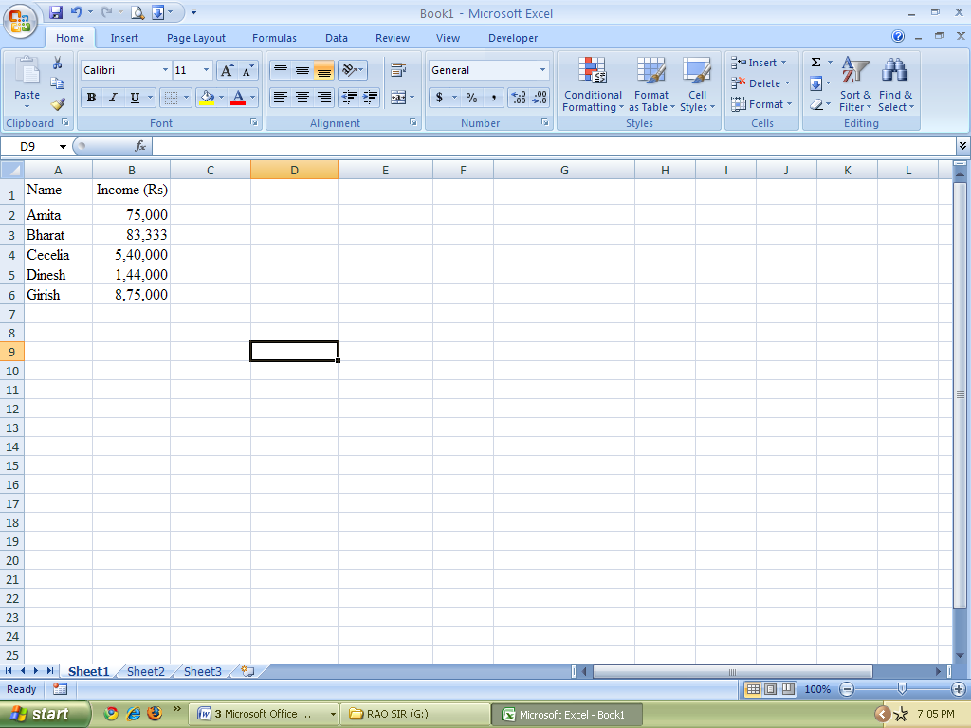

Calculate income tax in column C using the following policy.
Income Tax Rate
First Rs.50,00 0%
Next Rs.10,000 10%
Next Rs.90,000 20%
Excess 30%
Show the formula to your examiner.

Q.1 In MySQL, Create a database in your name and then create a table PRICES containing columns prod_ID (Product id primary key) PNAME (product name) and UPRICE (Unit Price) .
Add five rows to this table
Execute a query for the following:
- Display only the first 3 rows.
- Add a new column SPRICE to store selling price and update this field by storing selling price 15% more than the unit price.

Q.2 Write a C Program to input quantity and unit price of a product and then print the cost.
Q.3 Create the following worksheet in Excel:
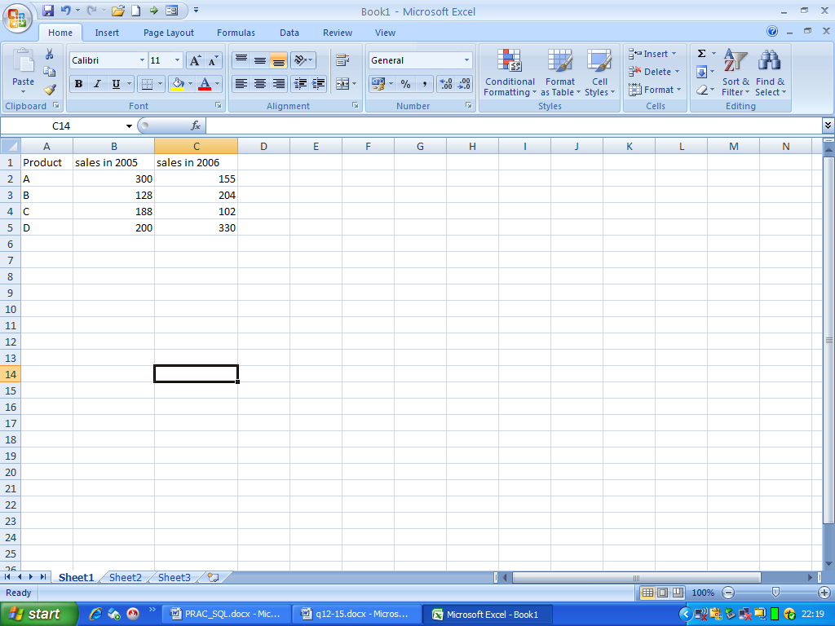

Create a column chart with A,B,C,D as category and sales as series.

Q.1 In MySQL, Create a database in your name and then create a table WAGES containing columns WORKER_ID (Worker id primary key) W_NAME ( name) and HRS (Hours worked),RATE (rate per hour).
Add five rows to this table
Execute a query for the following:
(i) Display worker id, name and wage of all workers.
(ii)Show all the rows in alphabetical order of Name.

Q.2 Write a C Program to find the sum of
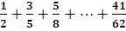

Q.3 Create the following worksheet showing data:

1) Find total and average in columns E and F.
2) Find Result in column G where result is “PASS” when average 50 or more otherwise “FAIL”.

Q.1 In MySQL, Create a database in your name and then create a table SALES containing columns SALES_ID (salesman id primary key) S_NAME ( name) and TSALES (Total sales).
Add five rows to this table
Execute a query for the following:
- Add one new column COMMI to the table to store commission.
(ii) Update the column commission as 3% of total sales.

Q.2 Write a C Program to input name and basic pay and print name and bonus where bonus is 25% of Basic.

Q.3 Create the following worksheet showing
Construct the following charts to display Month along X Axis and sales of the along Y Axis:
(a) A 3-D column chart
(b) A Line chart
(Show appropriate axis titles)

Q.1 In MySQL, Create a database in your name and then create a table SALES containing columns SALES_ID (salesman id primary key) S_NAME ( name) and TSALES (Total sales).
Add five rows to this table
Execute a query for the following:
- To show sum and average of total sales of all the employees.
- To display names of all salesmen whose names begin with the letter A

Q.2 Write a C program to print numbers from 1 to 100.
Q.3 Create the following worksheet showing

Calculate income tax in column C using the following policy.
Income Tax Rate
First Rs.50,00 0%
Next Rs.10,000 10%
Next Rs.90,000 20%
Excess 30%
Show the formula to your examiner.

